Laboratory – Profiling

4.1 Objective:
This laboratory exercises guide you how to measure the program’s performance using profiling. On completion of this laboratory, you should be able to
- Understand how to measure the program’s running time
- Be aware the importance of tuning your program to be faster

4.2 Procedure 1 - Profile

4.2.1 Activity 1 – familiarization with Profiling
Type the following program that is a simple one dimensional matrix. It will initialize it with a value of 1.0; it then forms two loops to initialize it.
float a[10000];
void assign(int i) {
int j;
for (j = 0; j <10000; j++)
a[i] = a[j];

}
void main() {
int i;
for (i = 0; i <10000; i++)
a[i] =1.0;
for (i = 0; i < 10000; i++)
assign(i);
}
Under the project, select setting and general, tick enable profiling as below.
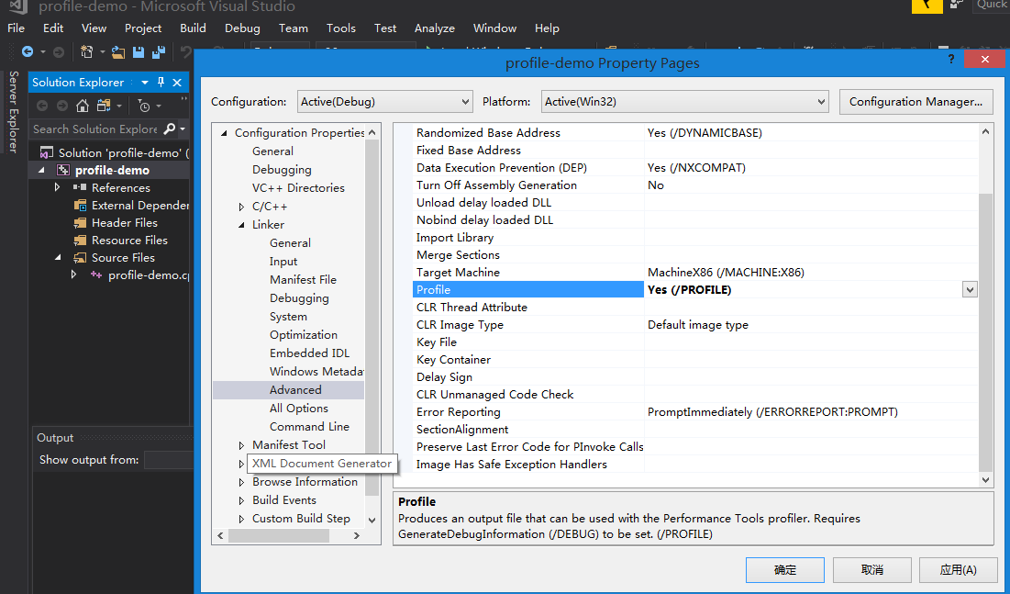

Rebuild the solution again.

Select “Debug”->”Profiler”->”performance profiler”. In the pop window click “Performance Wizard” then “start”.

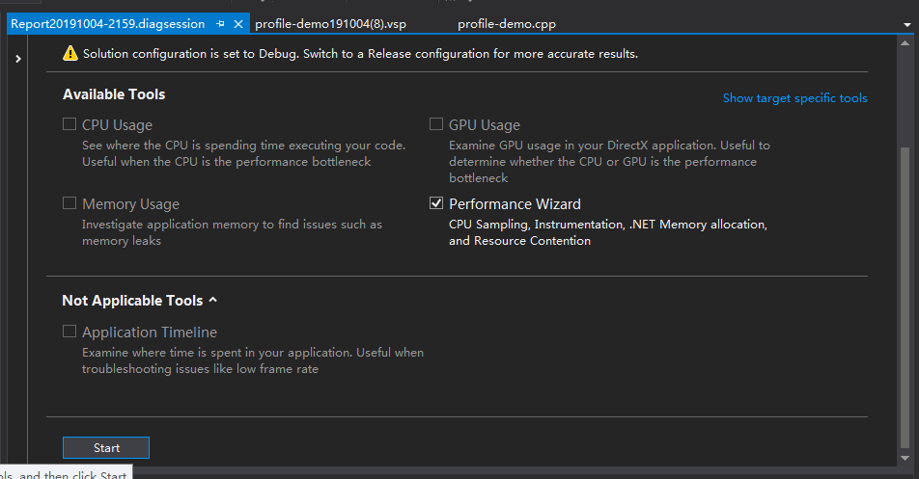

Then in the following window, select “Instrumentation”, then click next
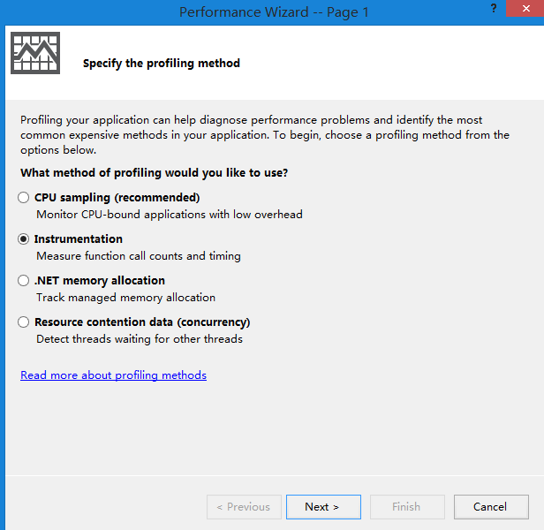
You will see that it displays the following window.
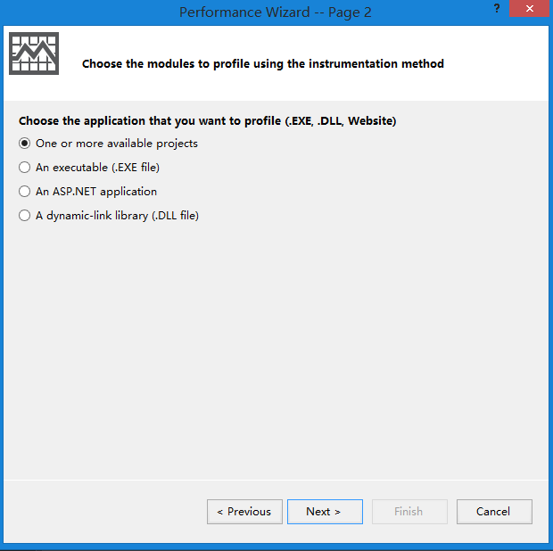

Use default settings until you click “finish”.
A report is generated for your project. In “Hot Path” you can see the percentage of CPU time spent by each function.
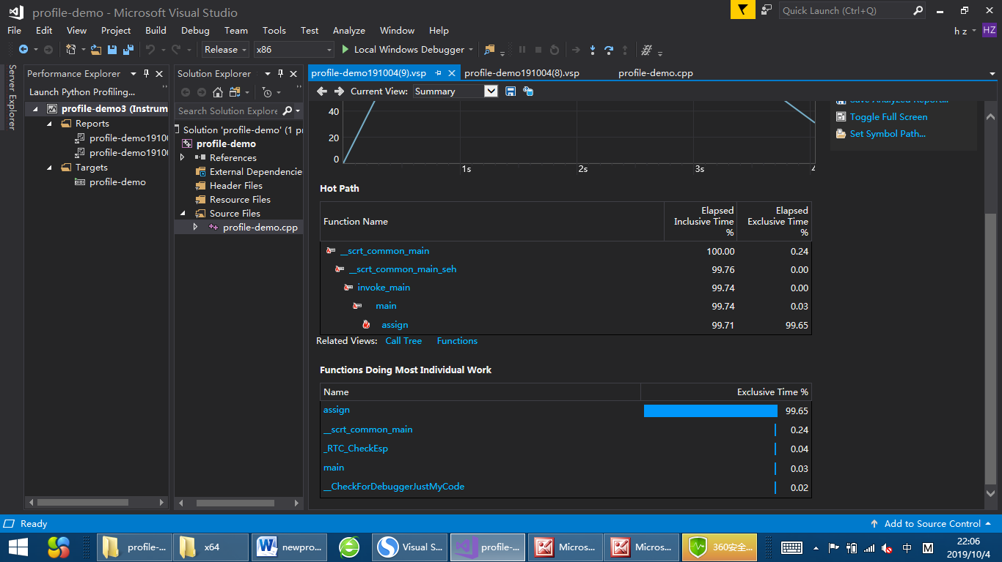

Now answer the following question so that you understand more about profiling. Complete the following from your system.

- Explain what does “Hot Path” mean?
在程序执行期间最通常的调用路径

2) What do elapsed exclusive time and inclusive time mean?
Elapsed exclusive time: 函数栈桢在栈顶时间比例
Inclusive time: 函数栈桢在栈上的时间时间比例

3) How can these profiling information help us in promoting a program performance?
能了解到那个函数的执行时间是最长的,可以优化它.

Now select Functions view as below.
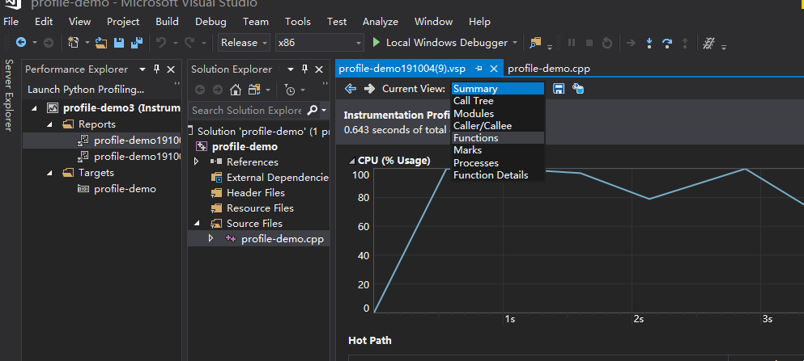

You will get function list as below. In this list you can inspect number of calls and elapsed inclusive time. The list releases very important information: if you can promote the performance of function assign, you can improve the program performance apparently.

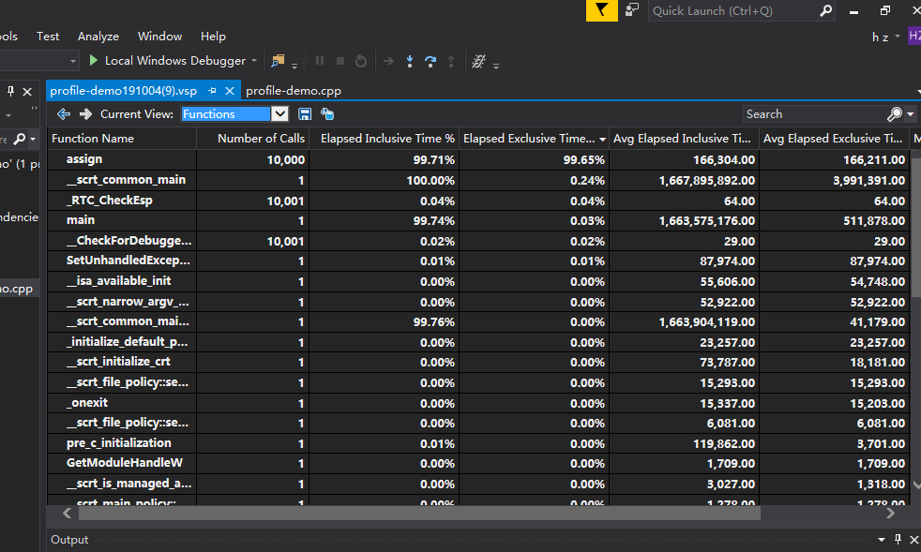

Now double click on “assign” you can get more details about this function.
It shows the caller function and called function of assign, and where the CPU time goes.

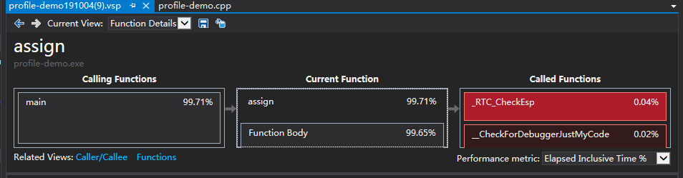

4.2.2 To learn more about MS VS Profiler

1.https://docs.microsoft.com/en-us/visualstudio/profiling/beginners-guide-to-performance-profiling?view=vs-2019

2. https://docs.microsoft.com/en-us/visualstudio/profiling/running-profiling-tools-with-or-without-the-debugger?view=vs-2019

